1

Sixth Form ​A Level​ ​English
Literature
Transition Booklet

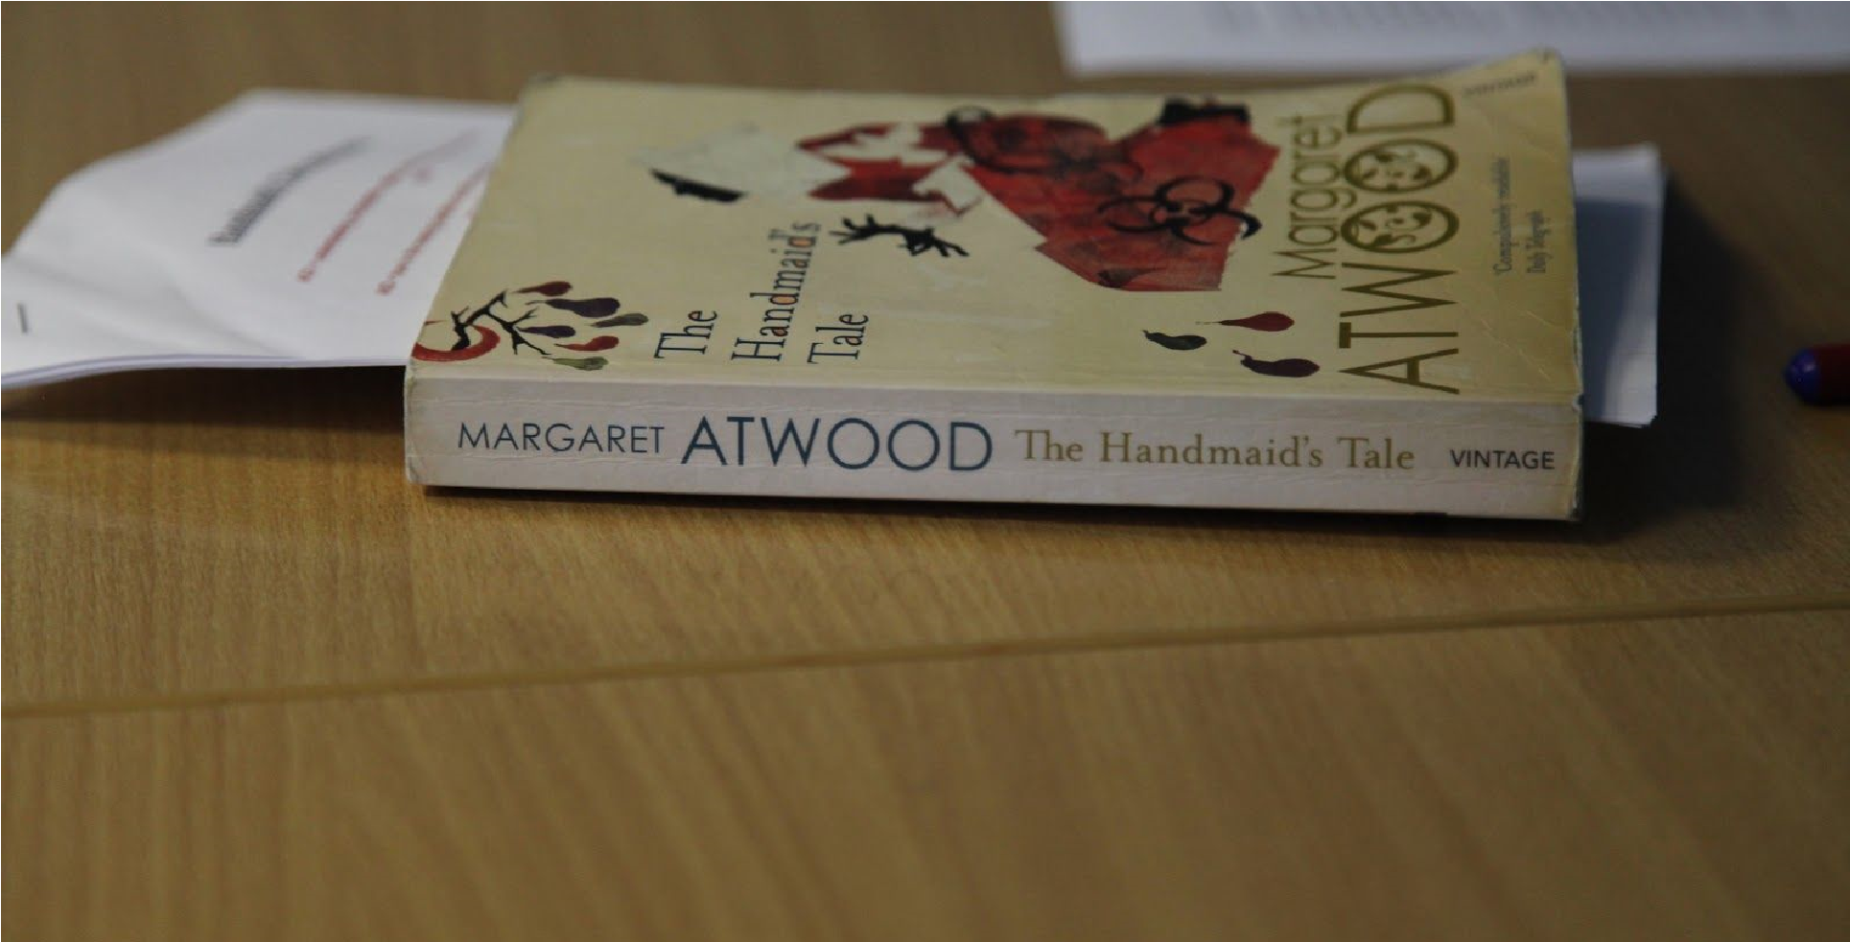

Name:
Welcome to English Literature at Elizabeth Woodville
This Transition work is designed to help you to bridge the gap between your GCSE studies and A Level.

Why do Transition work?
Preparation is crucial for studying A levels. A levels require you to be an independent learner. Although you have fewer subjects, A levels require different study skills and the volume of work is greater due to the increased demand of depth and detail. The exercises in this booklet will ensure that you are ready for the exciting challenges of becoming an A level student in September. It may be necessary to complete some of the tasks on separate sheets of paper. You have the choice of either typing or handwriting your responses. Each subject will be slightly different, but they will all require you to use the skills you will need for A level: independent enquiry; evidence of reading around the subject and enthusiasm and interest.
Summary of Exams for A- Level English Literature
Overview of assessment – Drama
- Written examination, lasting 2 hours and 15 minutes.
- Open book – clean copies of the drama texts can be taken into the examination. The Critical Anthology must not ​be taken into the examination.
- Total of 60 marks available – 35 marks for Section A and 25 marks for Section B.
- Two sections: students answer ​one ​question from a choice of ​two ​on their studied text for both Section A and Section B.
- Section A – Shakespeare: ​one ​essay question, incorporating ideas from wider critical reading (AO1, AO2, AO3, AO5 assessed).
- Section B – Other Drama: ​one ​essay question (AO1, AO2, AO3 assessed).
Overview of assessment – Prose
- Written examination, lasting 1 hour 15mins.
- Open book – clean copies of the prose texts can be taken into the examination.
- Total of 40 marks available.
- Students answer ​one ​comparative essay question from a choice of ​two ​on their studied theme (AO1, AO2, AO3, AO4 assessed).
Overview of assessment – Poetry
- Written examination, lasting 2 hours and 15 minutes.
- Open book – clean copies of the poetry texts can be taken into the examination.
- Total of 60 marks available – 30 marks for Section A and 30 marks for Section B.
- Two sections: students answer one question from a choice of two, comparing an unseen poem with a named poem from their studied contemporary text and one question from a choice of two on their studied movement/poet.
- Section A – Post-2000 Specified Poetry: one comparative essay question on an unseen modern poem written post-2000 and one named poem from the studied contemporary text (AO1, AO2, AO4 assessed).
- Section B – Specified Poetry Pre- or Post-1900: one essay question (AO1,AO2, AO3 assessed).
Overview of assessment - NEA (Non-Exam Assessment – Coursework)
- Comparison of two novels. One will be selected by the teacher, the other will be chosen by the student. Students will write their own question to answer.
- Students produce one assignment: ● one extended comparative essay referring to two texts (AO1, AO2, AO3, AO4, AO5 assessed) ● advisory total word count is 2500–3000 words ● total of 60 marks available.

Year 11 to Year 12 English Literature A-Level Transition Unit
TASK ONE:
What is Literature? [from Professor Terry Eagleton's 'Introduction to Literary Theory']
Have you ever felt ashamed or secretive about books you like because they are not on approved reading lists? Have you ever had a teacher, friend, or parent tell you that what you are reading isn’t “literature,” that it may have words printed on a page, but it is somehow inferior in quality to other books? That is, it might be “literature” in the broad sense of the term (words on a page) but it’s not “literary”? Well, the problem with such judgments is that if you press someone about their definition of “literature”, they will have a hard time finding a criteria that works for everything we have ever called literature. Although many have tried to define what “literature” is or what makes something “literary,” no one has successfully defined literature in such a way that it accounts for the complexities of language and the wide variety of written texts.
Critics suggest that literature is constructed from:
... imaginative writing;
... extraordinary language; ... pragmatic speech; .... "good" language.
So, to conclude, then...
“Literature” is highly subjective. We can’t decide whether or not something is “literature” simply by looking at its form or language. Shakespeare’s works have not always been valued as literature, and his works may not be valued in the future.
With that in mind, I'd like to introduce your first task...
Did you know that Bob Dylan, a famous American folk/blues/rock musician, surprisingly won the Nobel Prize for Literature in 2016 - "for having created new poetic expressions within the great American song tradition"? (If you've not heard of him, why not have a listen to 'Like a Rolling Stone' or 'Mr Tambourine Man'? You won't regret it!) Dylan's winning of the Nobel Prize caused some controversy at the time and was met with quite a mixed response; he was the first ever song-writer to receive the prize. Lebanese novelist, Rabih Alamedine, commented that "Bob Dylan winning a Nobel in Literature is like Mrs Fields (an American cookie brand) being awarded 3 Michelin stars." Nonetheless, Dylan's attainment of the prize is very interesting for us to consider - especially in terms of what this contributes to an understanding of literature.
To study literature is to study the human existence - their happiness, their hope, their sadness, their suffering. Music is, essentially, poetry accompanied by music, expressing some kind of aspect of the human existence and (hopefully) being understood. As the listener, it is our job to work out what it is they are trying to express....
What do I need to do?
- Choose a song that you love - that has meaning to you - and that you think would make for an interesting literary analysis. (Be kind to yourself here and choose a song that you know will be "rich" for literary analysis... don't just pick the first thing that comes to your head!)
- Find the lyrics of the song using your internet search engine.
- If you can, print the lyrics out and annotate them in as much detail as you can manage. If you can't print the lyrics, go through and pick out the words, phrases etc. that you'd like to explore more fully. Consider the following questions: What literary devices can I find within the lyrics? What is the effect of those devices? What meaning is the song-writer trying to convey?
- Write at least one side of A4 (typed, size 12), exploring the meaning or message in your song. You will need to craft a question to suit your lyrics, i.e.
- How does Florence Welsh present themes of happiness in 'The Dog Days are Over'? - Explore the ways Mumford and Sons present themes of hope in 'Lover of the Light'.
- How does *insert artist name* present themes of *insert theme* in *insert song title*?
- Explore the ways *insert artist name* present themes of *insert theme* in *insert song title*.
TASK TWO:
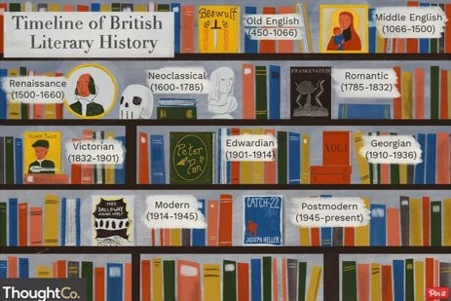

Create a detailed literary timeline, chronicling the following literary periods:
  - Classical
  - Old English / Medieval
  - Renaissance
  - Enlightenment
  - Romantic
  - Gothic
  - Victorian
  - Modernism
  - Post-modernism
For each period, find out the following:
- What, specifically, characterised this period in Literature? i.e. The Victorian period refers (mostly) to literature written during the reign of Queen Victoria (1837-1901). It is largely characterised by the struggle of working people and the triumph of "right" over "wrong". It is also often concerned with...
- Which writers were particularly prominent during this period? Is there anything interesting to be mentioned about these writers/texts? What were the most important texts written during this period? (And what were they about?) i.e. The Renaissance period was dominated by the works of Early-Modern playwright William Shakespeare who wrote plays such as 'Macbeth' and 'Othello'...
- Did any interesting historical/social/political events occur at the time which might have impacted the
literature produced at this time? | i.e. Shakespeare's writing reflects society's anxiety about a fear on
invasion - perhaps as a consequence of The Spanish Armada's threat of attack in 1588. As Queen Elizabeth did not have an heir - and as there was not a clear successor to her throne - people feared that a "foreigner" would come and take the English throne.

Your timeline can be produced in any format that you like; we would encourage you to be creative!

Useful resources which may help:
English Literature: Literary Periods and Genres - https://mc.libguides.com/eng/literaryperiods
The Literature Network - http://www.online-literature.com/periods/

TASK THREE:
Each task, moving forward, will explore a different period of English Literature – starting with the Medieval period.
To give you a flavour of the imagery which was typically used during the Medieval period, we are going to look at a poem written by Alfred, Lord Tennyson - who you may remember from 'The Charge of the
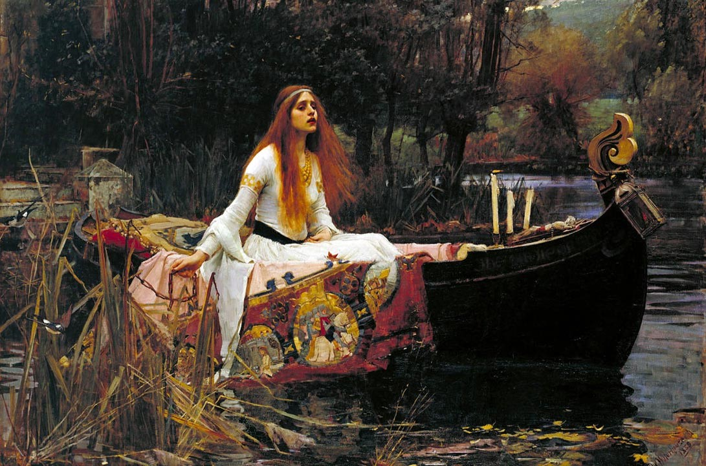
Light Brigade.' Now it is important to note that Tennyson was not a Medieval poet - in fact, he was writing much later in the Victorian period. However, his poem, 'The Lady of Shalott', really draws on Arthurian legend. Specifically, consider his presentation of Courtly Love and also consider the "stock characters" or archetypal characters you can identify in the poem. (Start by looking up "courtly love" and making notes on its definition. You can find a really good definition
here: https://condor.depaul.edu/dsimpson/tlove/courtlylove.html) painting by John William Waterhouse, 'The Lady of Shalott', (1888)
BREAKDOWN OF TASK:
- If you're able, I'd recommend that you start by printing a copy of the poem out. This will make it easier for you when it comes to your annotations. You will find a copy of the poem here: https://www.poetryfoundation.org/poems/45359/the-lady-of-shalott-1832
If you're not able to print it out, don't worry; you can just write down the lines / images / phrases that are particularly significant (when the time comes!).
- Next you need to listen to the poem. I'd really recommend that you listen to the version below which has been recorded by a number of celebrities (some of whom you may recognise) during lockdown: https://youtu.be/1EhzkCnPQew
- How does Tennyson present themes of love in the poem? Write an essay in response to this. Start by reading through the poem again, identifying/highlighting/underlining the instances where you think love has been presented. Can you identify any interesting features of language, structure, or form in your analysis? Any interesting word choices? Sentence types? Repetition? etc.
- Some of you may be interested in learning about the Arthurian legend which inspired Tennyson's poems - and will also be keen to understand as much of the context as possible. I'd recommend having a look here: https://www.ancient-origins.net/myths-legends-europe/arthurian-tale-elaine-astolat-lady-shalott003151 or here: https://eclecticlight.co/2017/07/16/elaine-of-astolat-or-the-lady-of-shalott/
- In terms of your essay, aim to write at least 4 paragraphs. This will require some detailed planning of what you're going to focus on in each paragraph.
Success Criteria:
- Make sure that you plan your ideas before putting pen to paper. I'd like to see evidence of your planning in the essay that you submit.
- Start each of your paragraphs with a line of argument that directly engages / answers the question and do not include a quotation or term in your opening sentence. Ideally, we should be able to read the first sentence of every paragraph and follow what you are "arguing" in your essay.
- Say a little about a lot. Look really closely at your quotations and try to dissect it in as much detail as you are able. What device/type of word has been used? What are the connotations? What is the effect? Link your ideas back to the Q.
- Where possible, try to link your ideas to context (A03). This could be the context of when the poem has been written, or context of when the poem has been set - it could even be Literary context, drawing upon ideas of Medieval Literature, Romantic Literature, Arthurian legend and the idea of Courtly love.
- Looking to push yourself? Try to include an interpretation from a literary critic. Do you agree with them or disagree with them? Try to engage with their argument and the point they are trying to make.
TASK FOUR:
- Watch Mrs McAloon's 'Introduction to Renaissance Literature' lesson which has been saved here: https://youtu.be/kH9vU-Fz7pk

2, Make bullet-pointed notes as you listen/watch the lesson - these notes will be really useful later in your studies of A-Level Literature.
THE TRIAL OF ONE MR WILLIAM SHAKESPEARE, FORMERLY OF STRATFORD-UPON-AVON
3. Watch this trailer for 2011 film, 'Anonymous': https://youtu.be/uBmnkk0QW3Q
This film draws upon the very famous authorship question surrounding Shakespeare's works...
Could a man who allegedly struggled to spell his own surname and had never left the country really tell tales of exotic, faraway places like Venice and Cyprus and Athens?
And, if not Shakespeare, then who? There has been much debated about the true (?) pen behind some of
Literature's most famous words. Sir Francis Bacon? The Earl of Oxford? Or - dare I say it - perhaps a
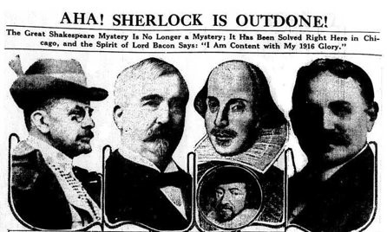
woman? Maybe even Queen Elizabeth I herself?! (Don't laugh; there's an actual argument for this!!) Or someone else entirely, hidden in the shadows, completely concealed from the public eye...

5. Research the authorship question surrounding Shakespeare's works. You need to outline the main suspects in the case and evaluate the credibility of the argument.
A few places to look to get you started... (Though, there are lots of websites/resources to explore, so don't just be limited to the sites posted below.)
- https://www.theguardian.com/culture/2010/mar/14/who-wrote-shakespeare-james-shapiro
- https://www.theguardian.com/childrens-books-site/2016/apr/23/shakespeare-authorship-questionteenage-readers
- https://news.stanford.edu/news/2013/march/physicist-shakespeare-plays-031813.html
- https://www.shakespeare.org.uk/explore-shakespeare/shakespedia/william-shakespeare/shakespeareauthorship-question/
- https://www.vox.com/2016/4/22/11480192/shakepeare-400-anti-stratfordian-authorship-controversy
When you're finished, please submit your research here: The Authorship Conspiracy (Make sure you include something about who you think truly authored the plays.)

TASK FIVE:
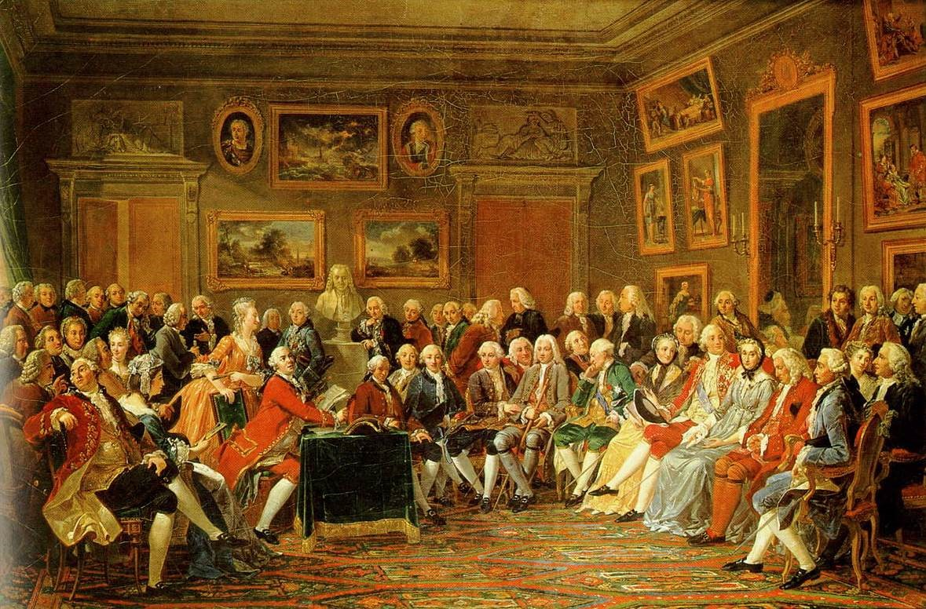

- Watch the recording Mrs McAloon's lecture exploring Literature of The Enlightenment period.
You can find the lecture here: https://youtu.be/sk0fqWhMuQU
- Ensure you make detailed, bullet pointed notes as you watch the lecture.
- Select a chapter (of your choosing) from Mary Wollstonecraft's A Vindication of the Rights of
Woman, which can be found here: https://www.earlymoderntexts.com/assets/pdfs/wollstonecraft1792.pdf
Or, alternatively, listen to the audio version, here: https://www.amazon.com/Vindication-RightsWoman/dp/B01AH8BT8G (Or, if you're looking to really challenge yourself and read the whole seminal feminist text - which is quite short - I think it would be a good use of time!)
The names of the chapters can be found below; choose one which specifically captures your interest. You may find it hard to read and understand that everything Wollstonecraft is arguing - don't worry, this is expected! It is, undoubtedly, a challenging text - and we don't expect you will everything that's going on - all that we ask is that you do your best with what you've got in front of you.
Chapter I: The Rights and Involved Duties of Mankind Considered
Chapter II: The Prevailing Opinion of a Sexual Character Discussed
Chapter III: The Same Subject Continued
Chapter IV: Observations on the State of Degradation to Which Woman Is Reduced by Various Causes
Chapter V: Animadversions on Some Writers Who Have Rendered Women Objects of Pity, Bordering on Contempt
Chapters VI and VII: The Effect Which an Early Association of Ideas Has upon the Character; Modesty-Comprehensively Considered, and Not as a Sexual Virtue
Chapters VIII and IX: Morality Undermined by Sexual Notions of the Importance of a Good Reputation;
Of the Pernicious Effects Which Arise from the Unnatural Distinctions Established in Society
Chapters X and XI: Parental Affection; Duty to Parents
Chapter XII: On National Education
Chapter XIII: Some Instances of the Folly Which the Ignorance of Women Generates; with Concluding Reflections on the Moral Improvement That a Revolution in Female Manners Might Naturally Be Expected to Produce
Read your chapter and write up a summary of what you've understood from the reading.
5. Watch Mrs Fox’s lecture on ‘The Rise of the Novel’: https://youtu.be/H6m76BQFkEg
Wider Reading List: You should aim to read at least three of the texts over the summer
- 1984, George Orwell
- A Brave New World, Aldous Huxley
- The Water Cure, Sophie Mackintosh
- Gulliver’s Travels, Jonathan Swift
- A Modest Proposal, Jonathan Swift
- The Feminine Mystique, Betty Friedan
- The Power, Naomi Alderman
- The Second Sex, Simone de Beauvoir
- The Crucible, Arthur Miller
- Death of a Salesman, Arthur Miller
- Witchcraft: A Very Short Introduction, Malcolm Gaskill
- The Colour Purple, Alice Walker
- Vox, Christina Dalcher
- A Vindication of the Rights of Woman, Mary Wollstonecraft
- Enquiry Concerning Political Justice, William Godwin
- The Rights of Man, Thomas Paine
- The Great Gatsby, F Scott Fitzgerald
- When She Woke, Hillary Jordan
- Romeo and Juliet, William Shakespeare
- Children of Men, Pd James
- The Rime of the Ancient Mariner, Samuel Taylor Coleridge
- Macbeth, William Shakespeare
- Mary Shelley, Muriel Spark
- Selected Poems: Keats (Penguin Classics) Paperback – 26 Apr 2007
- Prometheus Bound, Aeschylus
- Prometheus, Lord Byron
- Prometheus Unbound, Percy Shelley
- Paradise Lost, John Milton
- Who Runs the World, Virginia Bergin
- Essay Concerning Human Understanding, John Locke

